1. **Cloning the development repository:**

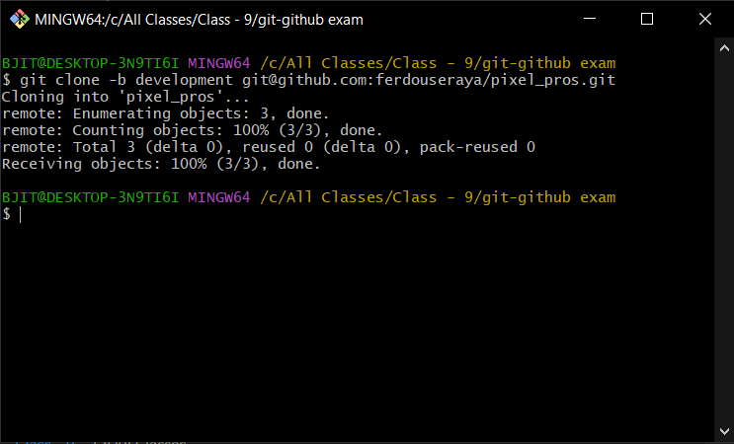

1. **Creating new branch:**

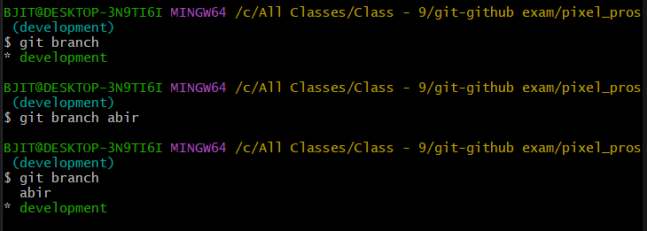

1. **Pulling changes in development branch:**

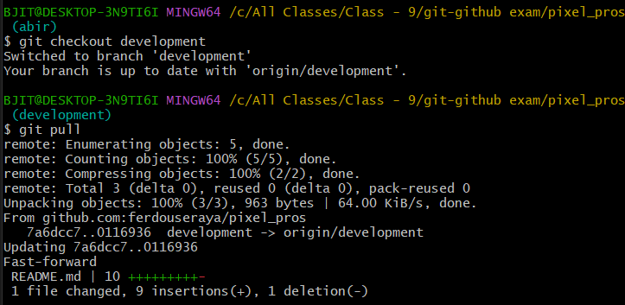

1. **Changing Branch:**

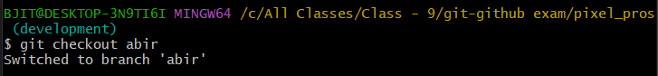

1. **Adding and comitting changes to local repository:**

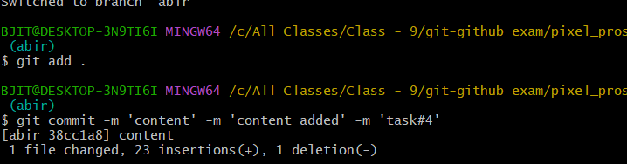

1. **Pulling from the development branch:**

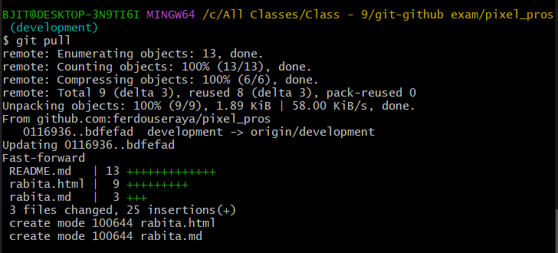

1. **Changing branch:**

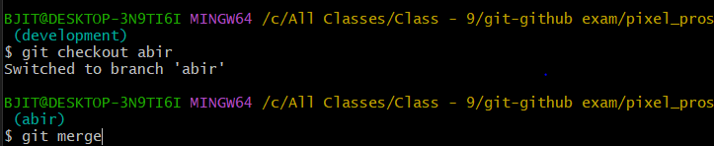

1. **Merging with developent branch:**

**Conflict created:**

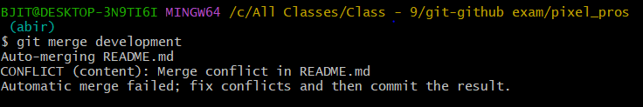

**Conflict Issue:**

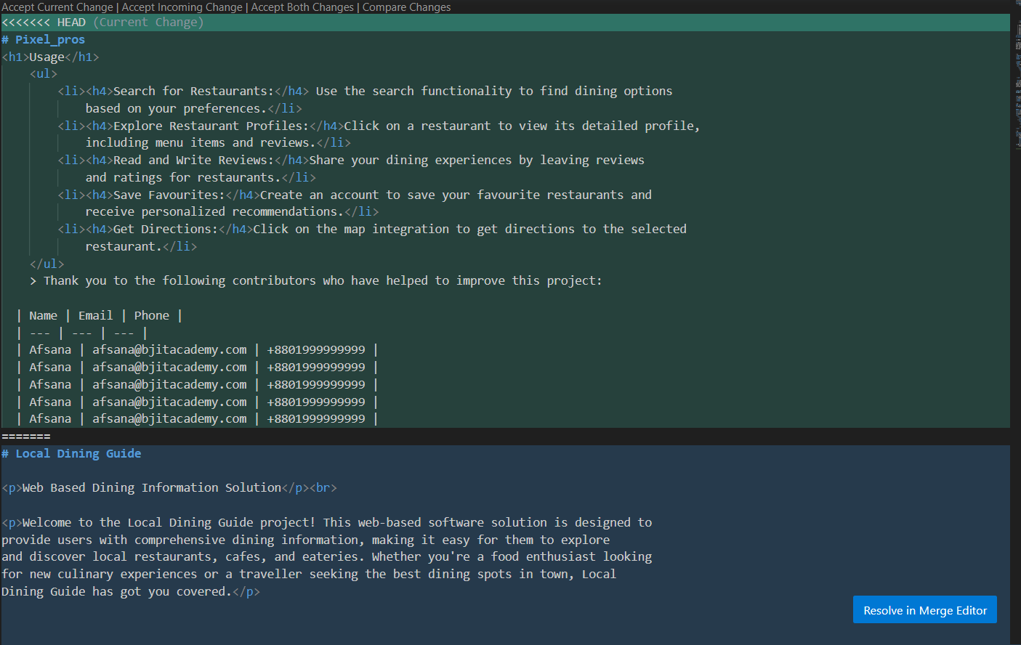

1. **Conflict resolved and branch pushed:**

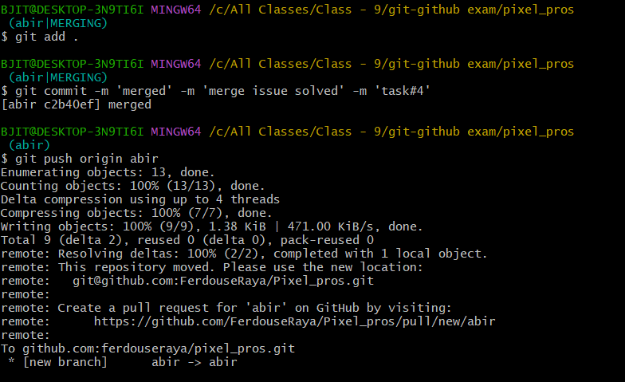

1. **Review added and approved:**

